
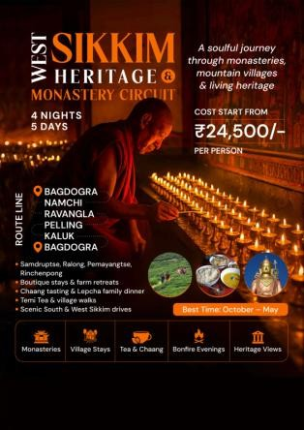
WEST SIKKIM HERITAGE & MONASTERY CIRCUIT
Duration: 4 Nights / 5 Days
Theme: Heritage, Monasteries, Culture & Himalayan Villages
Best Season: October – May
Start / End: Bagdogra / NJP

TOUR OVERVIEW
Discover the soul of Sikkim through a heritage journey across South and West Sikkim. This slow- paced cultural circuit blends monastery visits, scenic drives, tea gardens, and village interactions — offering a glimpse into Sikkim’s timeless spirituality.
Perfect for culture lovers, photographers, and boutique travelers seeking authentic experiences beyond the typical tourist route.

SUGGESTED ROUTE
Bagdogra – Namchi – Ravangla – Pelling – Rinchenpong – Kaluk

DAY-WISE ITINERARY

Day 1 – Bagdogra / NJP → Namchi (90 km / 4 hrs)
- Scenic drive via Teesta valley
- Visit Char Dham Complex & Samdruptse Monastery
- Explore Temi Tea Garden with a tea-tasting session
- Evening at leisure in Namchi Bazaar

Day 2 – Namchi → Ravangla → Pelling (85 km / 4–5 hrs)
- Visit Ralang Monastery and Buddha Park (Tathagata Tsal)
- Stop at Bon Monastery (unique Bon faith monastery)
- Continue to Khecheopalri Lake
- Visit Pemayangtse Monastery & Rabdentse Palace Ruins



Day 3 – Pelling Monastery Circuit
- Early hike to Sanga Choeling Monastery
- Visit Skywalk & Chenrezig Statue viewpoint
- Explore Darap Village & enjoy organic lunch
- Evening free for café hopping or local bazaar

Day 4 – Pelling → Rinchenpong / Kaluk (45 km / 2 hrs)
- Visit Rinchenpong Monastery & Yangsum Heritage Farmhouse
- Walk through pine forest trails and orange orchards
- Experience Lepcha hospitality with a traditional meal
- Bonfire & storytelling session in the evening
- Taste the traditional local brew, Chaang, served warm in bamboo mugs — a symbol of Sikkimese hospitality

Day 5 – Departure to Bagdogra (130 km / 5–6 hrs)
- Drive via Soreng & Jorethang
- End of Tour


STAY OPTIONS

Category | Namchi | Pelling | Kaluk / Rinchenpong
Premium | Summit Banari Regency | Chumbi Mountain Retreat / The Elgin Mount Pandim | Yangsum Heritage Farmhouse
Comfort | Summit Banari Regency | Norbu Ghang Retreat & Spa / Kaya Gantavya | Ghonday Village Resort
Economy | Hotel Maenamla / Cherry Resort | Mount Magnolia | Kaluk Homestay

INCLUSIONS
- Accommodation for 4 Nights with Breakfast & Dinner
- Exclusive vehicle for the entire trip (Innova / Xylo)
- Driver’s allowance, fuel, parking & permits
- Sightseeing as per itinerary
- All applicable hotel taxes

EXCLUSIONS
- Airfare fare to Bagdogra
- Lunches, personal expenses, and entry fees
- GST, insurance, and camera/video charges
- Anything not mentioned under “Inclusions”

MAJOR HIGHLIGHTS
- Monasteries: Samdruptse, Ralong, Pemayangtse, Sanga Choeling, Rinchenpong
- Experiences: Temi Tea, Bon Monastery, Lepcha village dinner
- Scenic drives, nature trails & farm life stays
- Authentic Local experience — Chaang tasting, Temi Tea session & Lepcha family dinner Perfect blend of heritage and serenity

